Task 1: Inspect inodes, directories and links
Output:
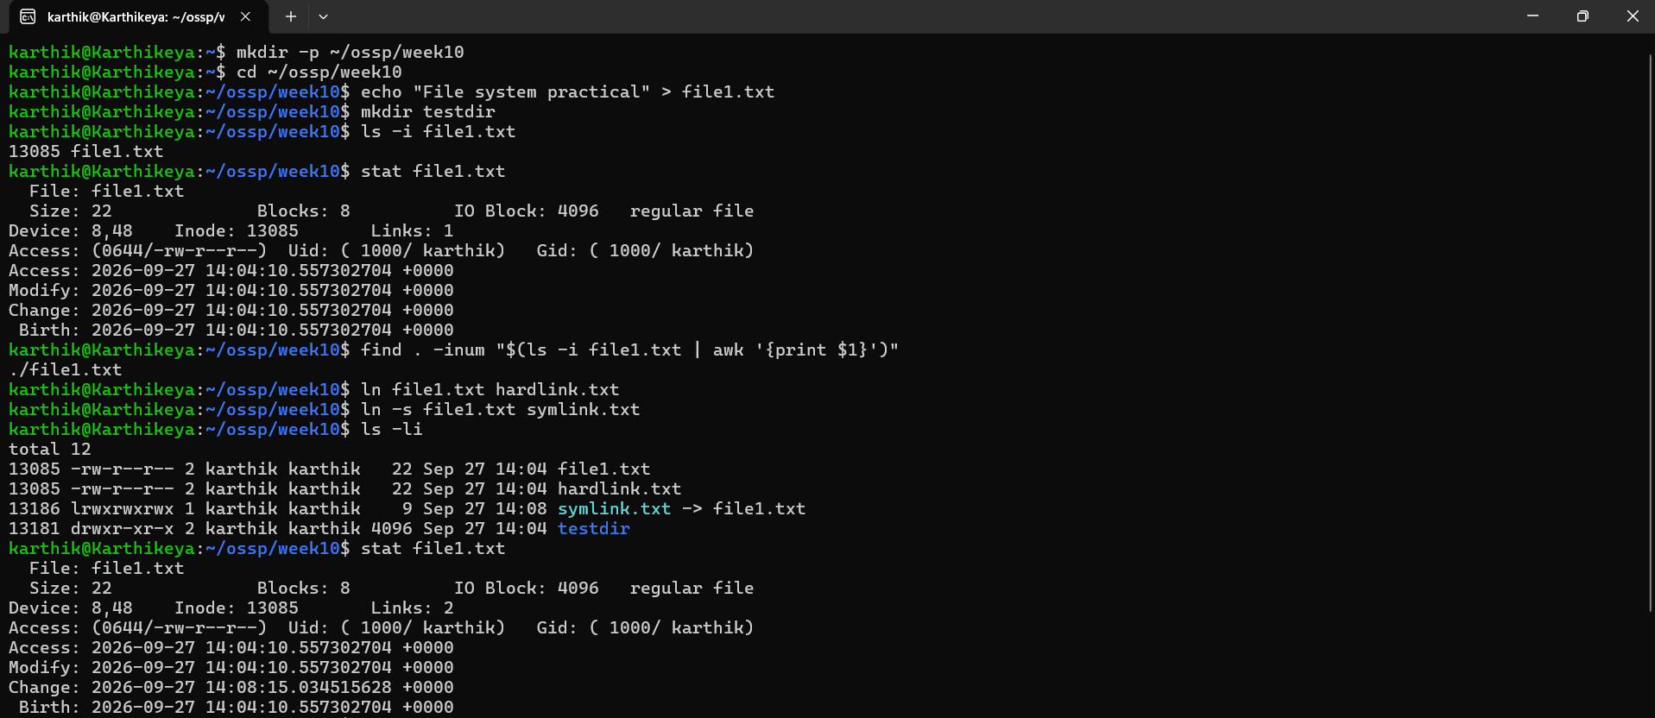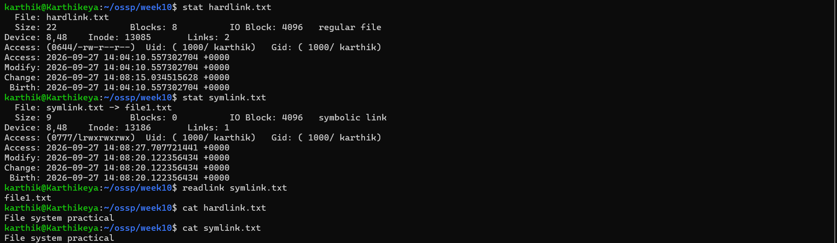

Task 2: Read and write files using mmap()
Code:
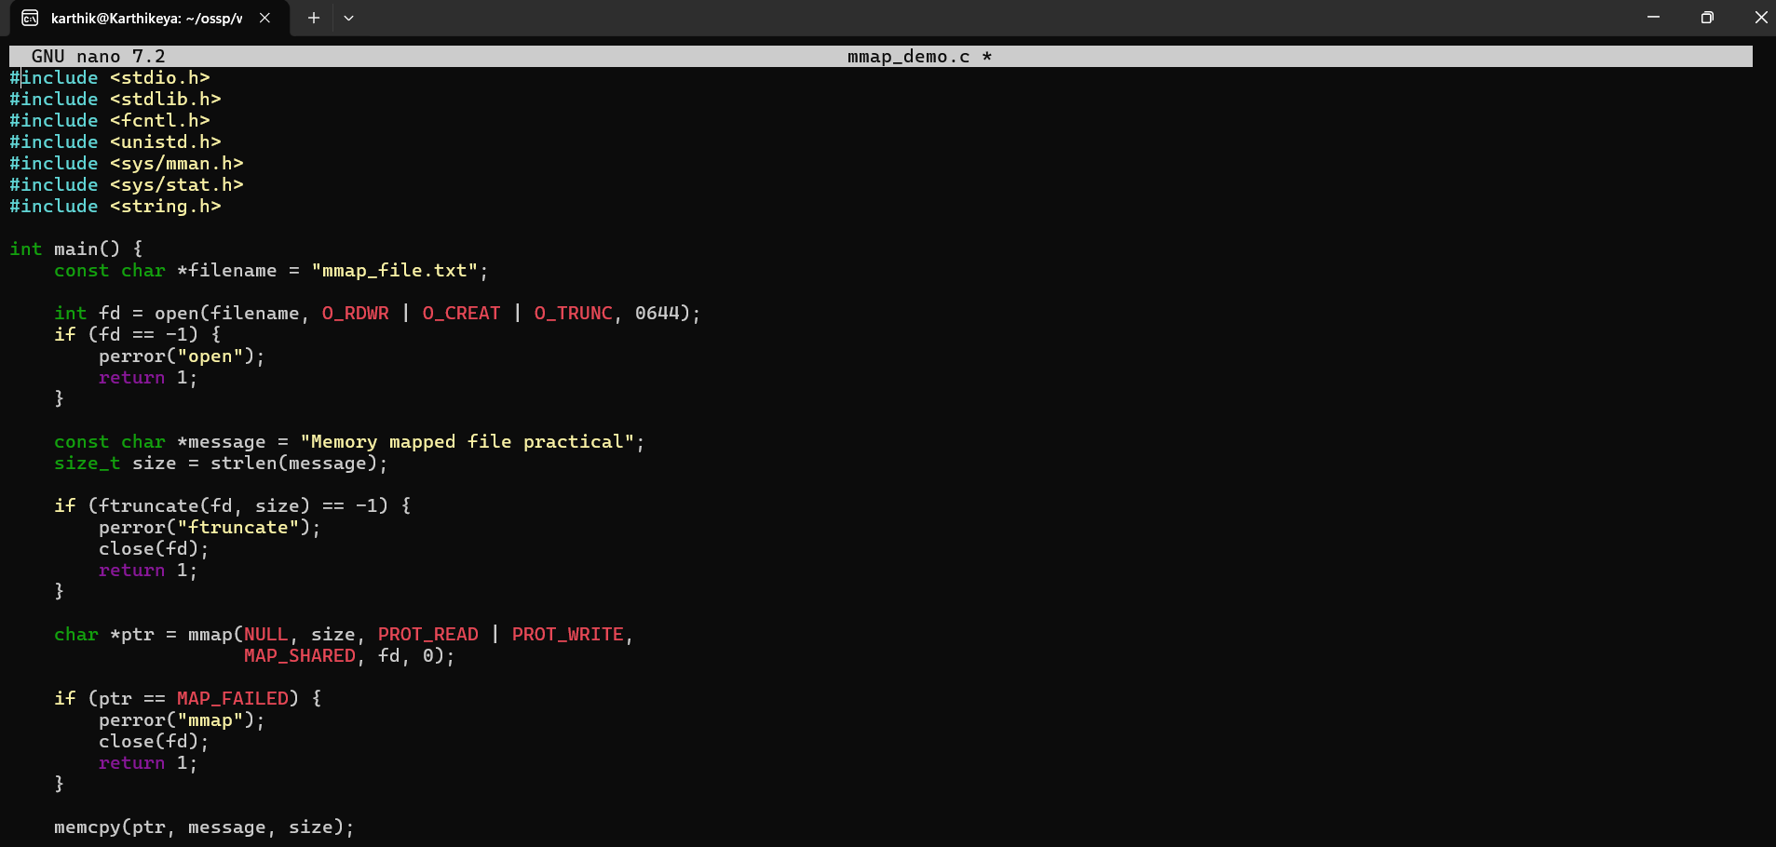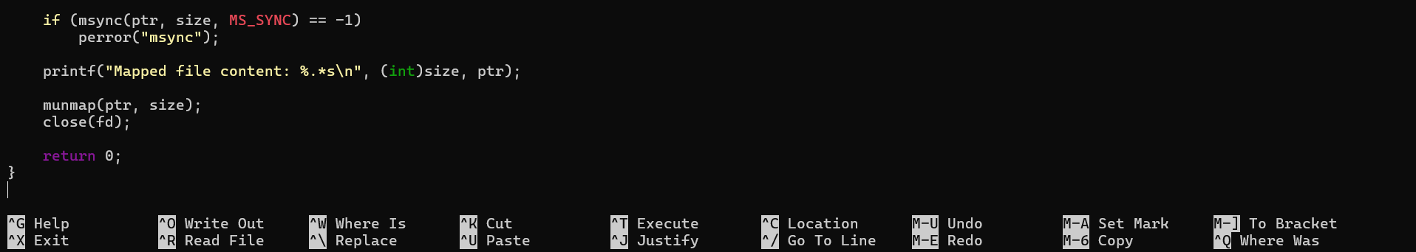

Output:

